**SKYHACK 2.0- UNITED AIRLINES-**(Query and output snippets)

After reviewing the data, I imported it into SQL Server Management Studio (SSMS). Using the 'calls' table, I calculated the average AHT (Average Handle Time) and AST (Average Speed to Answer) for each agent. Our call center has a total of 383 agents. Below is the SQL query along with its output for calculating the average AHT and AST for each agent.

##Query screenshot

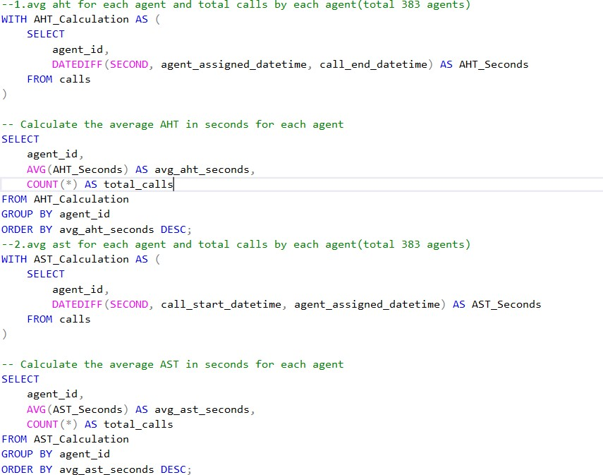

##output screenshot

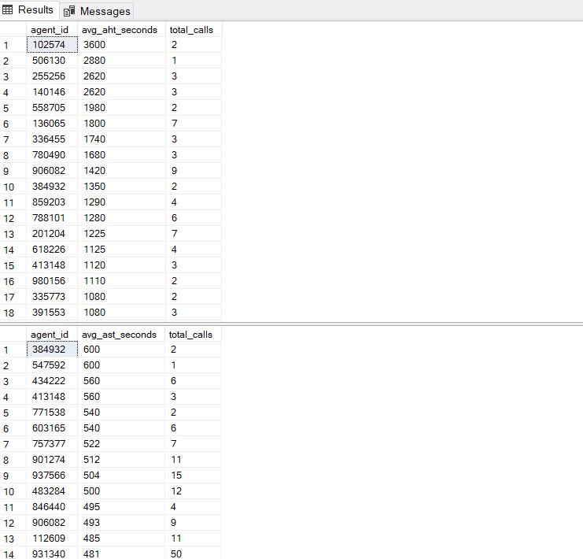

After calculating these metrics, I added two new columns to the 'calls' table using the following query:

ALTER TABLE calls

ADD AHT_Seconds INT,

AST_Seconds INT;

UPDATE calls

SET

AHT_Seconds = DATEDIFF(SECOND, agent_assigned_datetime, call_end_datetime),

AST_Seconds = DATEDIFF(SECOND, call_start_datetime, agent_assigned_datetime);

Next, I evaluated the average AHT and AST for each call reason. There are 20 distinct call reasons in the 'reasons' table, which were identified after cleaning the data.

##CLEANING OF DATA(REASONS TABLE(removing spaces hyphens etc)

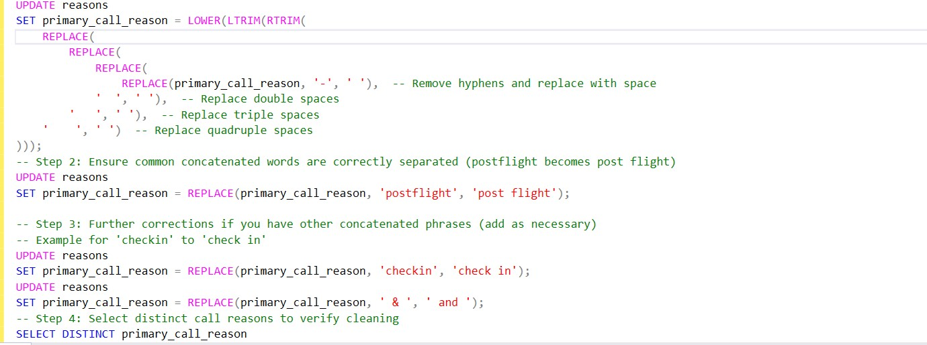

After data cleaning, we identified 20 distinct call reasons. I calculated the average AHT for each reason to determine the percentage difference between the most frequent and least frequent call reasons.

## query for finding out avg aht and avg ast by each call reason

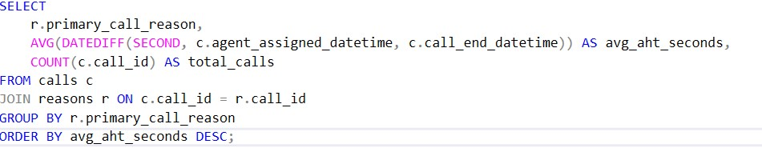

Now we can proceed to calculate the percentage difference

## The following query calculates the percentage difference by first finding the average AHT for the most frequent and least frequent call reasons: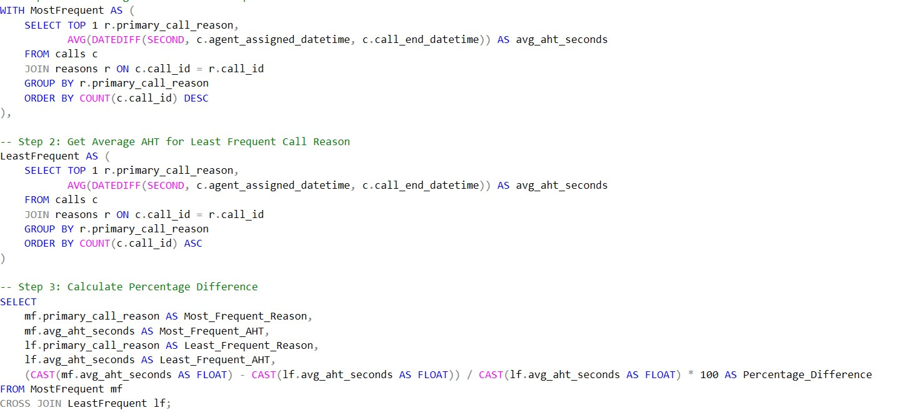

## Output

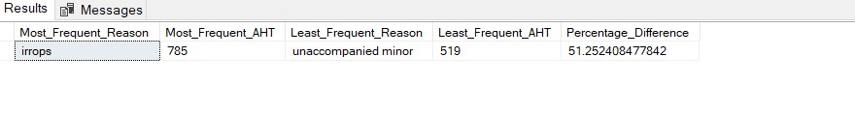

**I'm getting approximately a 51% percentage difference.**

After completing this, I plan to proceed with analyzing call volume trends.

I have defined time ranges in a day

**Morning**: 6 AM to 11 AM

**Afternoon**: 12 PM to 5 PM

**Evening**: 6 PM to 9 PM

**Night**: 10 PM to 5 AM

I have calculated the number of incoming calls, along with the average AHT and AST, for each period of the day.

##query+result

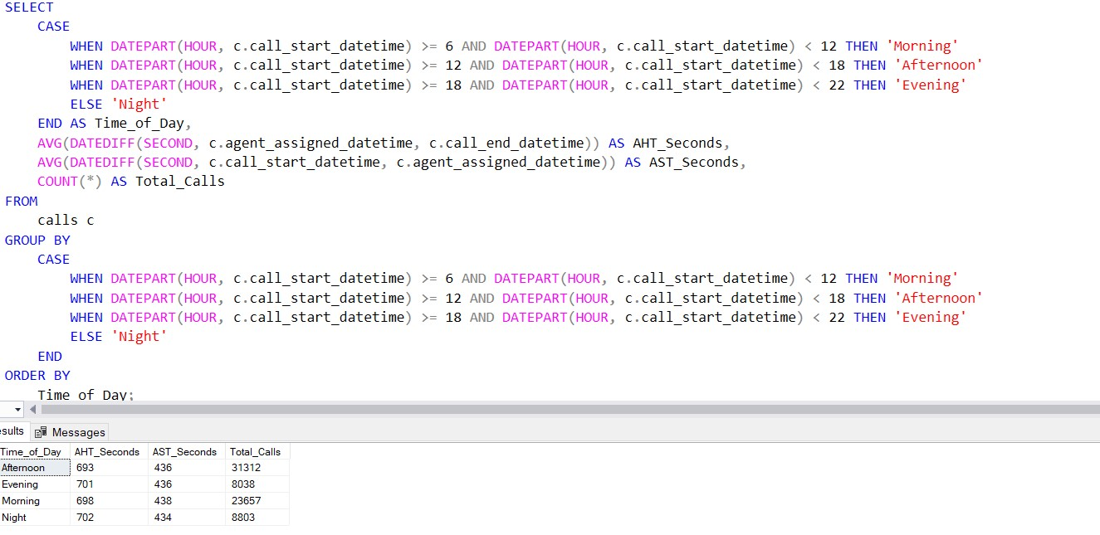

It is evident that the total number of calls is highest during the morning and afternoon time ranges, while the average AHT and AST remain relatively consistent across all time periods.

Additionally, I have conducted a call volume trend analysis by weekday. Below are the query and its output in the screenshot.

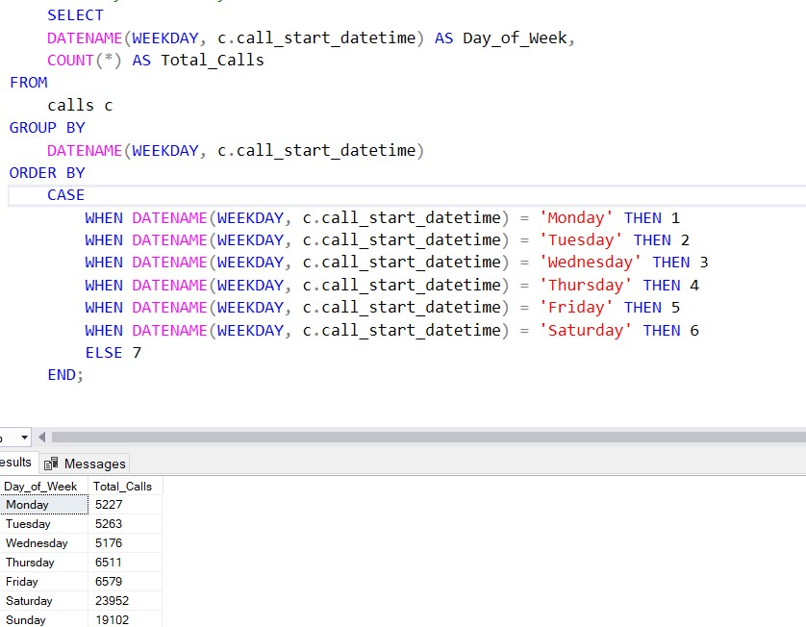

We can clearly observe that on weekends, the number of calls is nearly four times higher than on normal weekdays, indicating a significant increase in call traffic at the call center.

Having completed this analysis, I will now begin evaluating agent performance among the total of 383 agents by calculating the average AHT for each agent. This will establish a baseline for understanding how each agent performs relative to their peers.

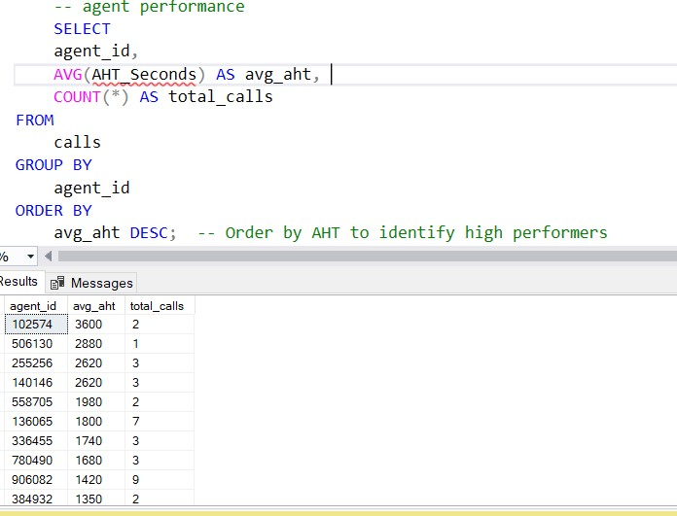

Based on the calculated average AHT, you can filter to identify agents who consistently have a high AHT. This analysis will help pinpoint those who may require additional training or support.

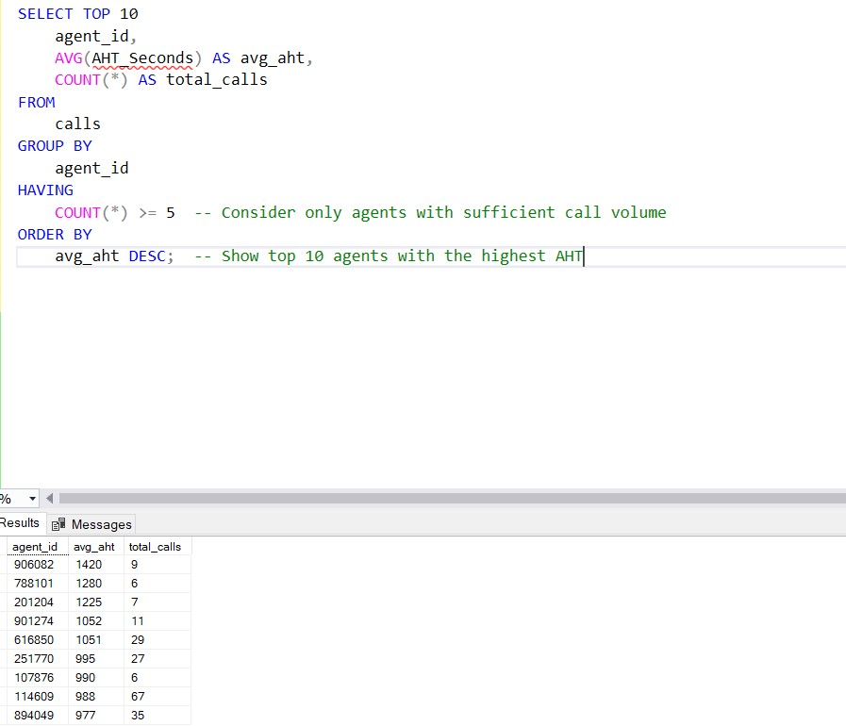

Agents who consistently have a high AHT require further training or assistance.

To analyze performance more thoroughly, you should examine the average AHT for each agent based on different call reasons. This will help identify if specific agents are struggling with particular types of calls.

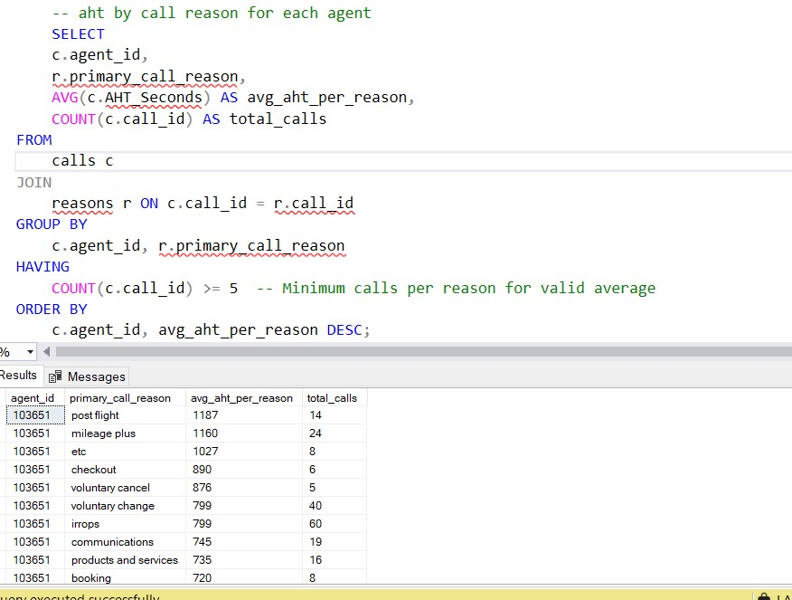

I am working with 3,600 rows of data and have simplified the results for further analysis.

We can identify agents with the highest and lowest average AHT for each call reason. This analysis will help determine which agents are performing well and which may need additional training.

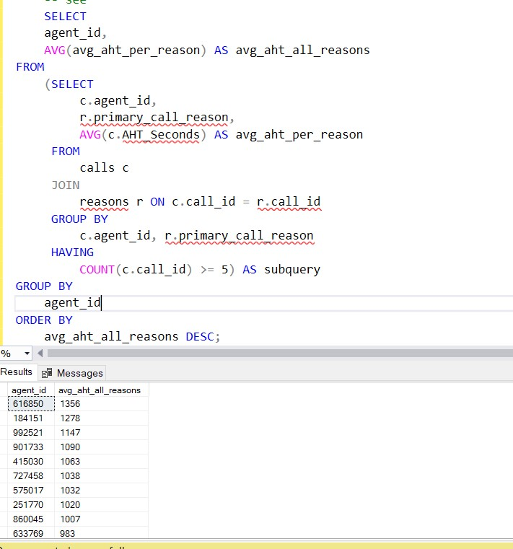

Furthermore, we can examine trends in AHT across different call reasons. For instance, if specific reasons consistently result in higher AHT, it may indicate processes that require optimization.

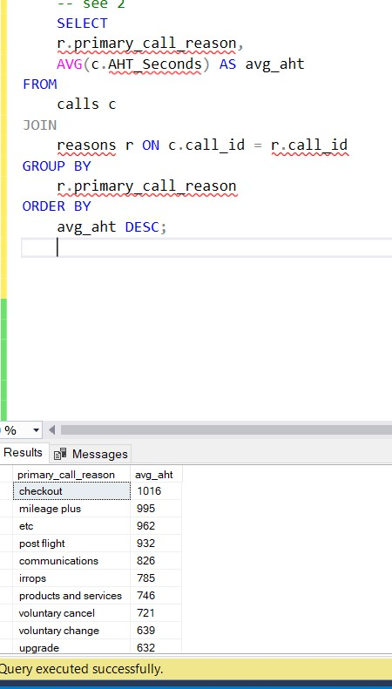

Analyzing customer interaction in relation to the time of day (average sentiment versus time of day).

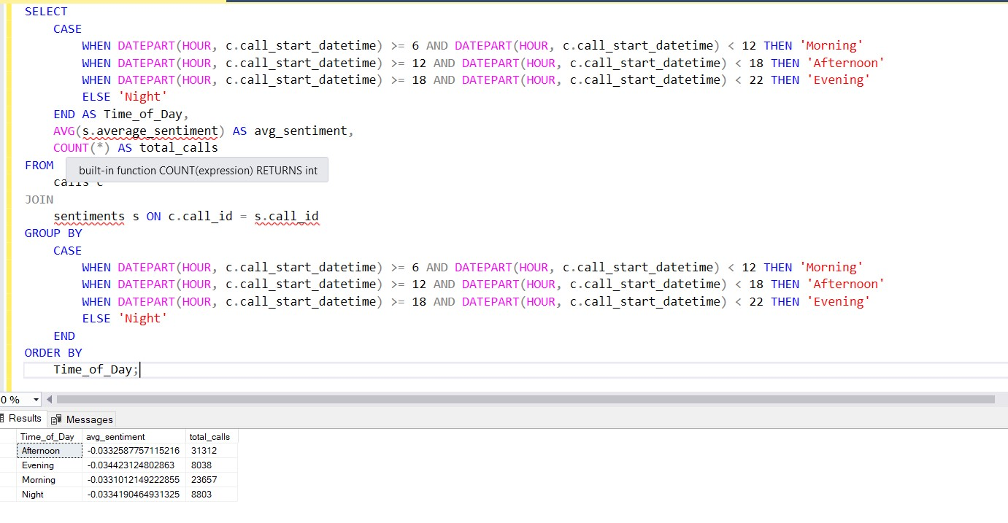

The average sentiment is approximately -0.03 across all time ranges, indicating that customer interactions are generally perceived as neutral to slightly negative, regardless of the time of day. This consistency could be attributed to:

1. **Sentiment Scoring Calibration:** Ensure that the sentiment scores are appropriately calibrated. If the scoring ranges from -1 (negative) to +1 (positive), a value close to zero suggests neutral customer sentiment, while values around -0.03 indicate slight negativity throughout all periods.
2. **Overall Service Experience:** If customer sentiment remains relatively unchanged throughout the day, it may suggest a broader trend where the overall experience is not significantly varying.

Following this analysis, I want to identify which call reasons exhibit a higher percentage of silence, allowing us to optimize those specific call reasons.

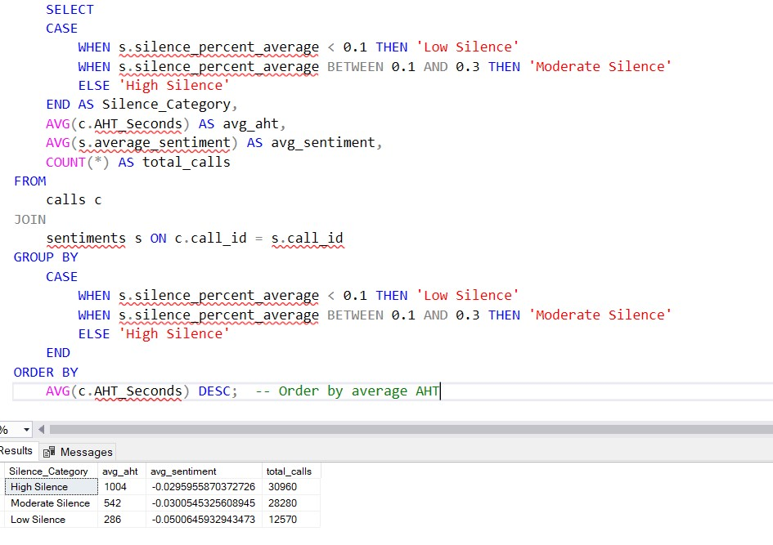

We can observe that the average AHT for the silence category is significantly higher. Now, we can identify the call reasons associated with high levels of silence.

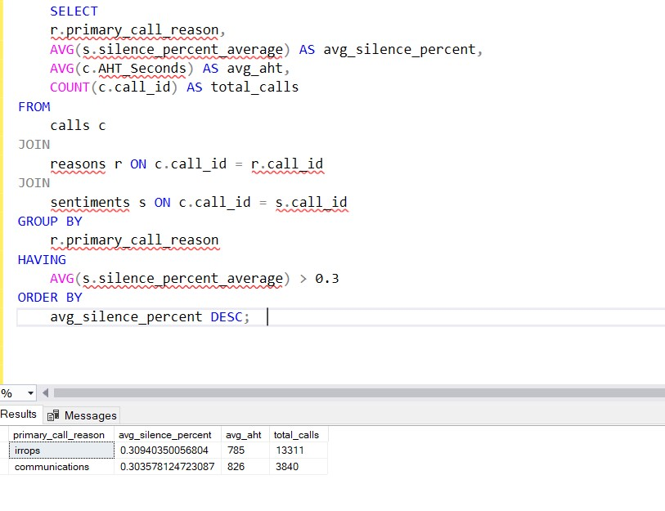

**We can see that for the call reasons 'irregular operations' and 'communication,' the average silence is high, indicating that these processes can be optimized.**

Now we can proceed with the analysis of speed to answer by call reasons.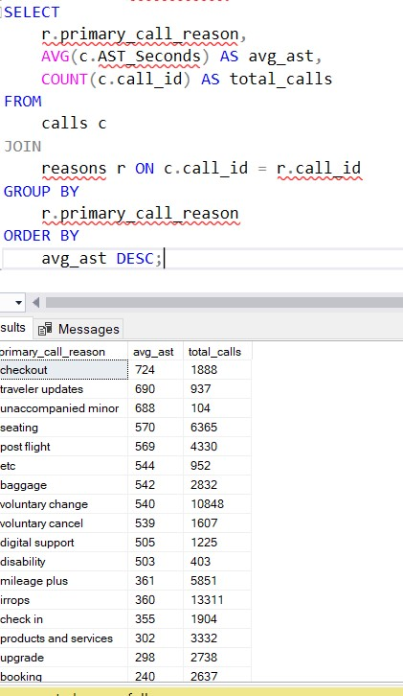

We can identify the call reasons with high AST, indicating that calls for those reasons take longer to answer. This suggests that we can assign more agents to those issues and further optimize the process.

Regarding high volume periods and AST, there is a consistent AST across all time periods of the day, which does not yield any actionable insights from this analysis.